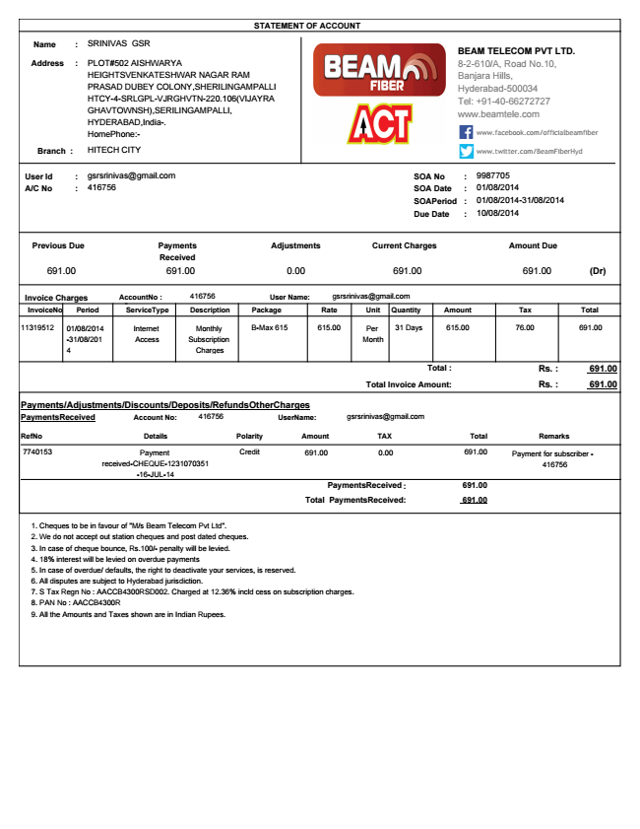

**Amount Due**

**691.00 (Dr) Invoice Charges AccountNo : 416756 User Name: gsrsrinivas@gmail.com InvoiceNo Period ServiceType Description Package Rate Unit Quantity Amount Tax Total 11319512 01/08/2014**

-31/08/201 4

Internet

Monthly

B-Max 615 615.00 Per 31 Days 615.00 76.00 691.00 Access

Subscription

Month Charges

**Total : Rs. : 691.00 Total Invoice Amount: Rs. : 691.00 Payments/Adjustments/Discounts/Deposits/RefundsOtherCharges PaymentsReceived**

Account No: 416756 UserName: gsrsrinivas@gmail.com

**RefNo Details Polarity Amount TAX Total Remarks**

7740153 Payment

received-CHEQUE-1231070351 -16-JUL-14

Credit 691.00 0.00 691.00 Payment for subscriber -

416756

PaymentsReceived : 691.00 Total PaymentsReceived : 691.00 1. Cheques to be in favour of "M/s Beam Telecom Pvt Ltd". 2. We do not accept out station cheques and post dated cheques. 3. In case of cheque bounce, Rs.100/- penalty will be levied. 4. 18% interest will be levied on overdue payments 5. In case of overdue/ defaults, the right to deactivate your services, is reserved. 6. All disputes are subject to Hyderabad jurisdiction. 7. S Tax Regn No : AACCB4300RSD002. Charged at 12.36% incld cess on subscription charges. 8. PAN No : AACCB4300R 9. All the Amounts and Taxes shown are in Indian Rupees.

**STATEMENT OF ACCOUNT**

**Address**

**Name :**

SRINIVAS GSR

**:**

**A/C No**

: 416756

BEAM TELECOM PVT LTD. 8-2-610/A, Road No.10, Banjara Hills, Hyderabad-500034 Tel: +91-40-66272727 www.beamtele.com

PLOT#502 AISHWARYA HEIGHTSVENKATESHWAR NAGAR RAM PRASAD DUBEY COLONY,SHERILINGAMPALLI HTCY-4-SRLGPL-VJRGHVTN-220.106(VIJAYRA GHAVTOWNSH),SERILINGAMPALLI, HYDERABAD,India-. HomePhone:-

Branch : HITECH CITY

9987705 User Id

**: SOA No**

: SOA Date : 01/08/2014 SOAPeriod : 01/08/2014-31/08/2014 Due Date : 10/08/2014

**Current Charges Previous Due**

691.00 691.00 0.00 691.00

www.facebook.com/officialbeamfiber

www.twitter.com/BeamFiberHyd

gsrsrinivas@gmail.com

**Adjustments Payments Received**



**Ξινζ ΑΜΣΤιο ΕΕΕΤΤ**

**R 66 7727 727**

**Highest :-) needs**

Highest Doolimits

Now Up To 50% Extra Downloads G. Jet Speed LEmbps@ros EEE EEmera gesaaise

சகோ

الH بي بي سي بيr